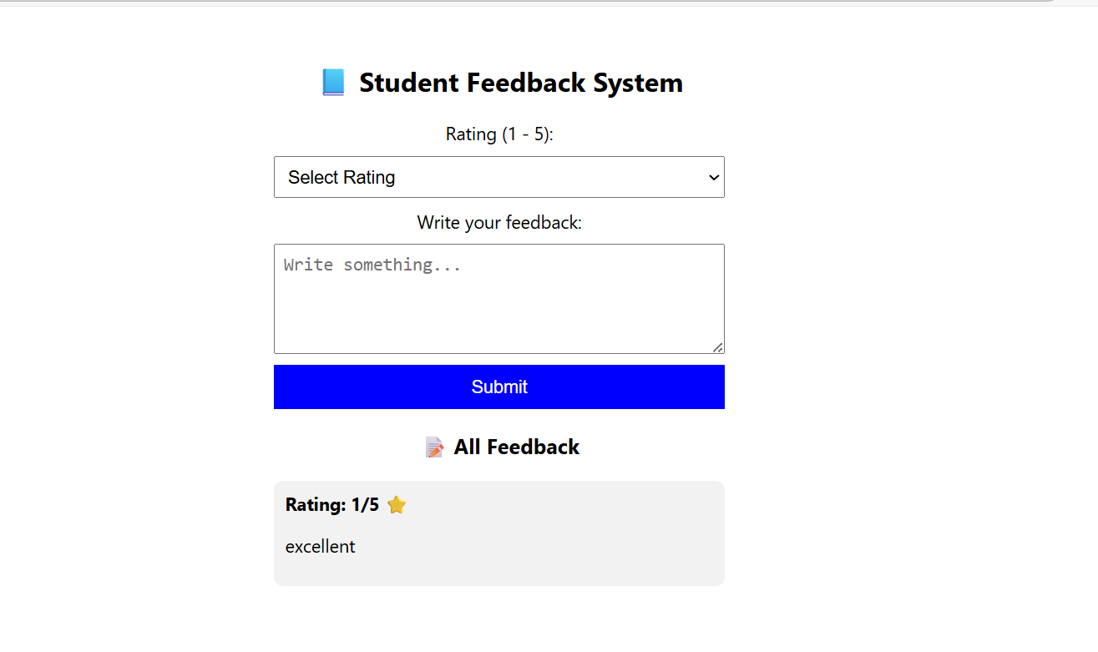
import React, { useState } from "react";

function App() {
const [rating, setRating] = useState("");
const [comment, setComment] = useState("");
const [feedbackList, setFeedbackList] = useState([]);

const handleSubmit = (e) => {
e.preventDefault();

if (!rating || comment.trim() === "") {
alert("Please give rating & comment!");
return;
}

const newFeedback = { rating, comment };
setFeedbackList([...feedbackList, newFeedback]);

setRating("");
setComment("");
};

return (
<div style={styles.container}>
<h2>📘 Student Feedback System</h2>

<form onSubmit={handleSubmit} style={styles.form}>
<label>Rating (1 - 5):</label>
<select
value={rating}
onChange={(e) => setRating(e.target.value)}
style={styles.input}
>
<option value="">Select Rating</option>
{[1, 2, 3, 4, 5].map((num) => (
<option key={num} value={num}>{num}</option>
))}
</select>

<label>Write your feedback:</label>
<textarea
value={comment}
onChange={(e) => setComment(e.target.value)}
placeholder="Write something..."
style={styles.textarea}
/>

<button type="submit" style={styles.btn}>Submit</button>
</form>

<h3>📝 All Feedback</h3>
{feedbackList.length === 0 ? (
<p>No feedback yet...</p>
) : (
feedbackList.map((fb, index) => (
<div key={index} style={styles.card}>
<strong>Rating: {fb.rating}/5 ⭐</strong>
<p>{fb.comment}</p>
</div>
))
)}
</div>
);
}

const styles = {
container: { width: "400px", margin: "auto", textAlign: "center", paddingTop: 30 },
form: { display: "flex", flexDirection: "column", gap: "10px", marginBottom: "20px" },
input: { padding: "8px", fontSize: "16px" },
textarea: { padding: "8px", height: "80px", fontSize: "16px" },
btn: { padding: "10px", background: "blue", color: "white", fontSize: "16px", border: "none", cursor: "pointer" },
card: {
background: "#f2f2f2",
padding: "10px",
borderRadius: "8px",
marginBottom: "10px",
textAlign: "left"
}
};

export default App;

